

Assignment -1

Name – Akhil Dubey

Roll – 2020UCO1673

Branch – COE-3

**Questions**

1. Read an image into a variable

2. Display that image

3. Convert the image into a grayscale image

4. Check the height and width of that image

5. Extract the RGB channels of a given colour image

6. To extract given 100 pixels from a grayscale image

7. Create a new image with every 10th pixel horizontally and 20th pixel vertically.

8. Flip the image vertically

9. Draw the histogram plot of pixel values.

import cv2

import numpy as np

a=cv2.imread(r"nature.jpg")

loc=r"nature.jpg"

#Display image

from PIL import Image

im=Image.open(loc)

im.show()

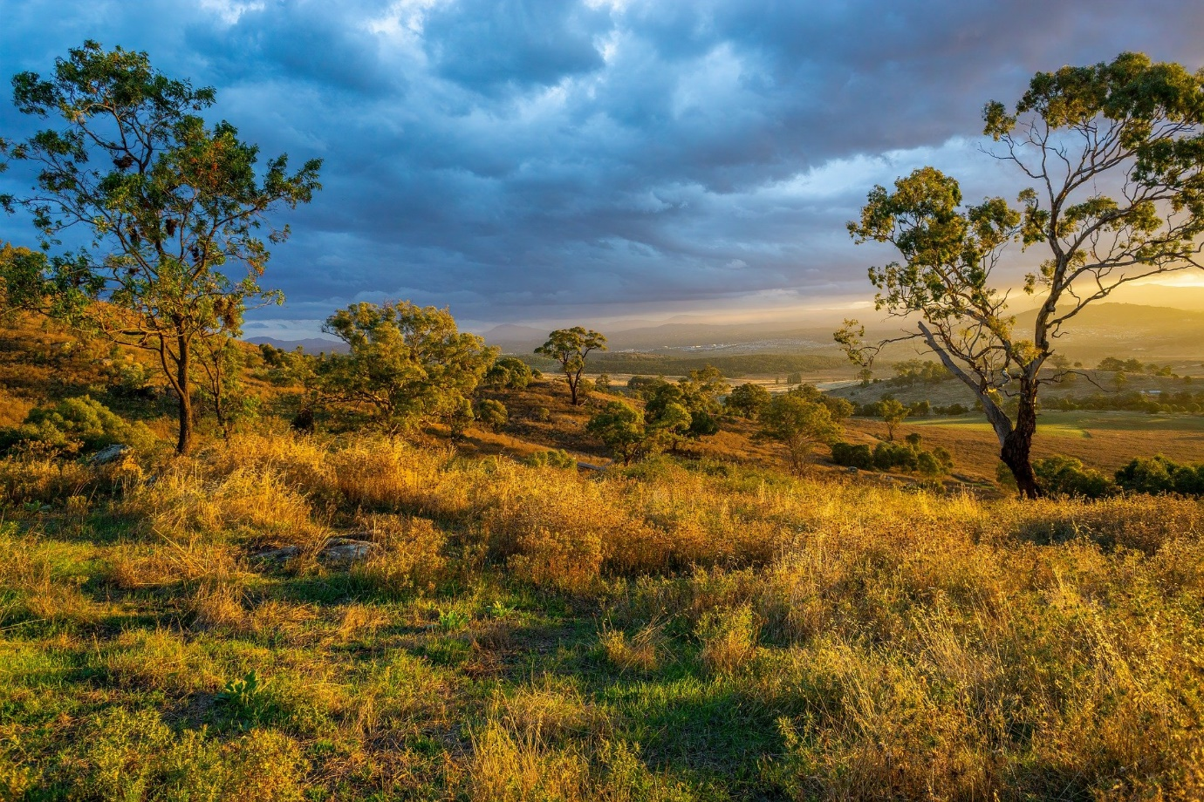

#Conversion to grayscale

b=[[sum(i)//3 for i in j]for j in a]

b.shape

b=np.array(b,dtype="uint8")

type(a)

type(b)

data=Image.fromarray(b)

data.save("grey.jpg")

img=Image.open("grey.jpg")

#Grayscale

img.show()

#dimensions of the image

b.shape

a.shape

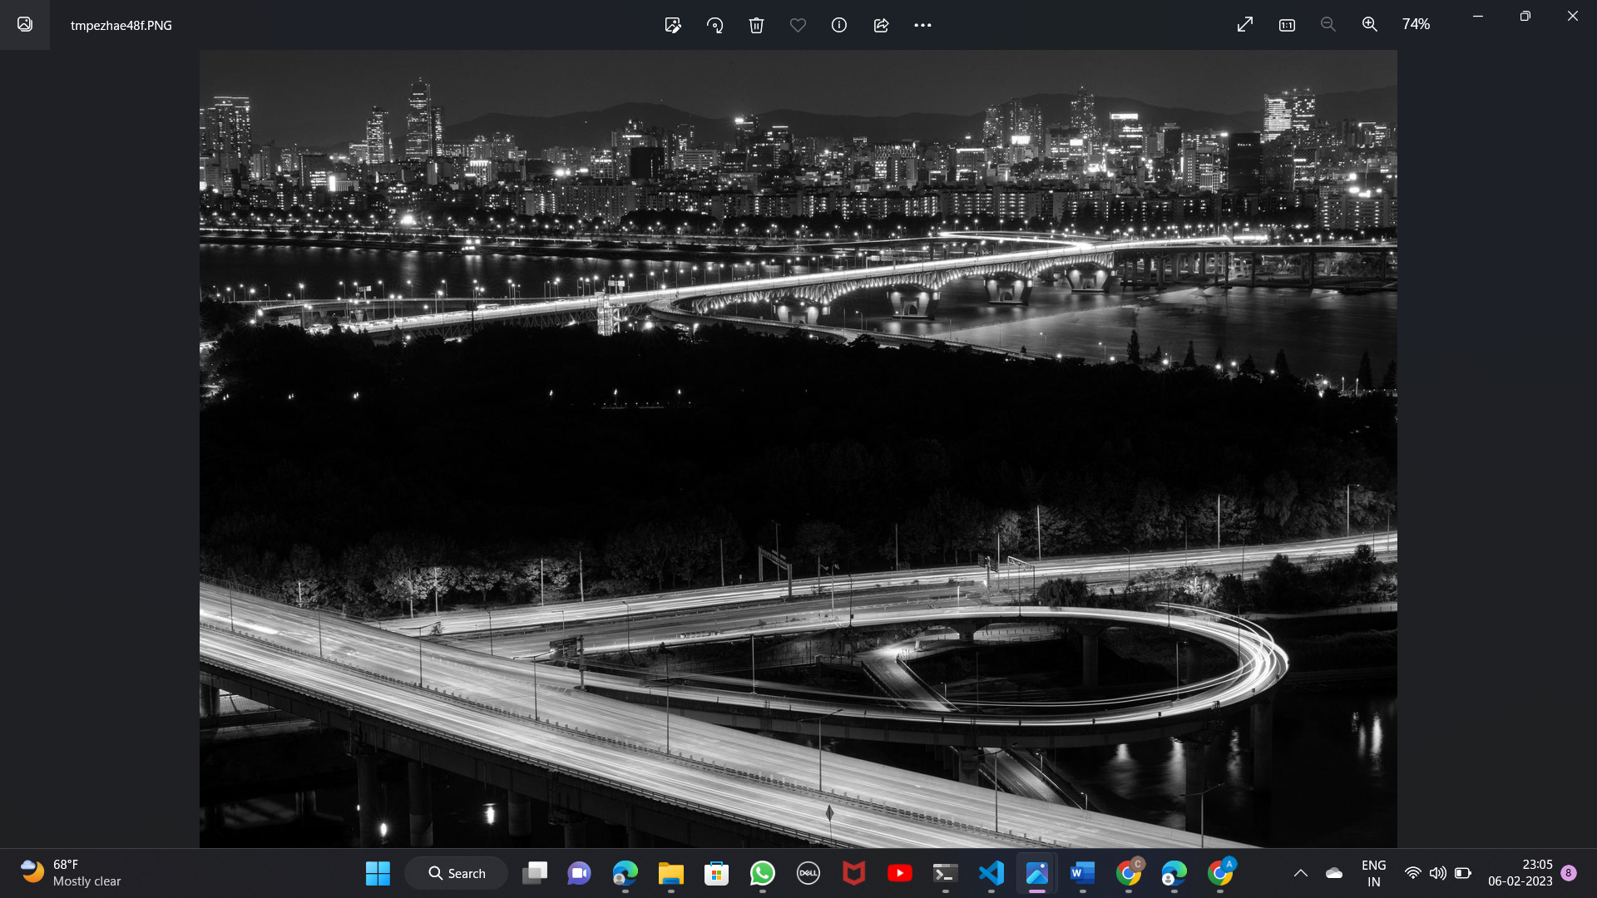

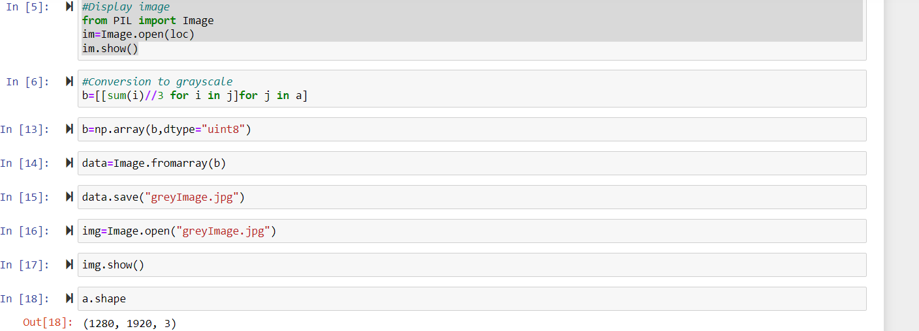

#channel red

red=[[[i[0],0,0] for i in j] for j in a]

red=np.array(red,dtype="uint8")

dr=Image.fromarray(red)

dr.save("red.jpg")

im=Image.open("red.jpg")

im.show()

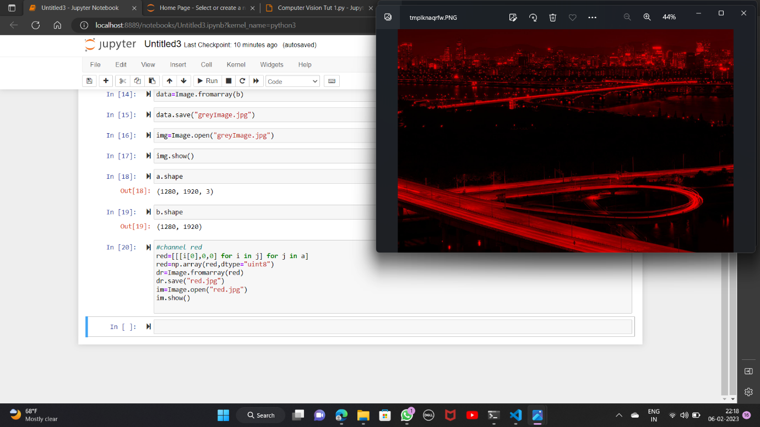

#channel green

green=[[[0,i[1],0] for i in j] for j in a]

green=np.array(green,dtype="uint8")

dr=Image.fromarray(green)

dr.save("green.jpg")

im=Image.open("green.jpg")

im.show()

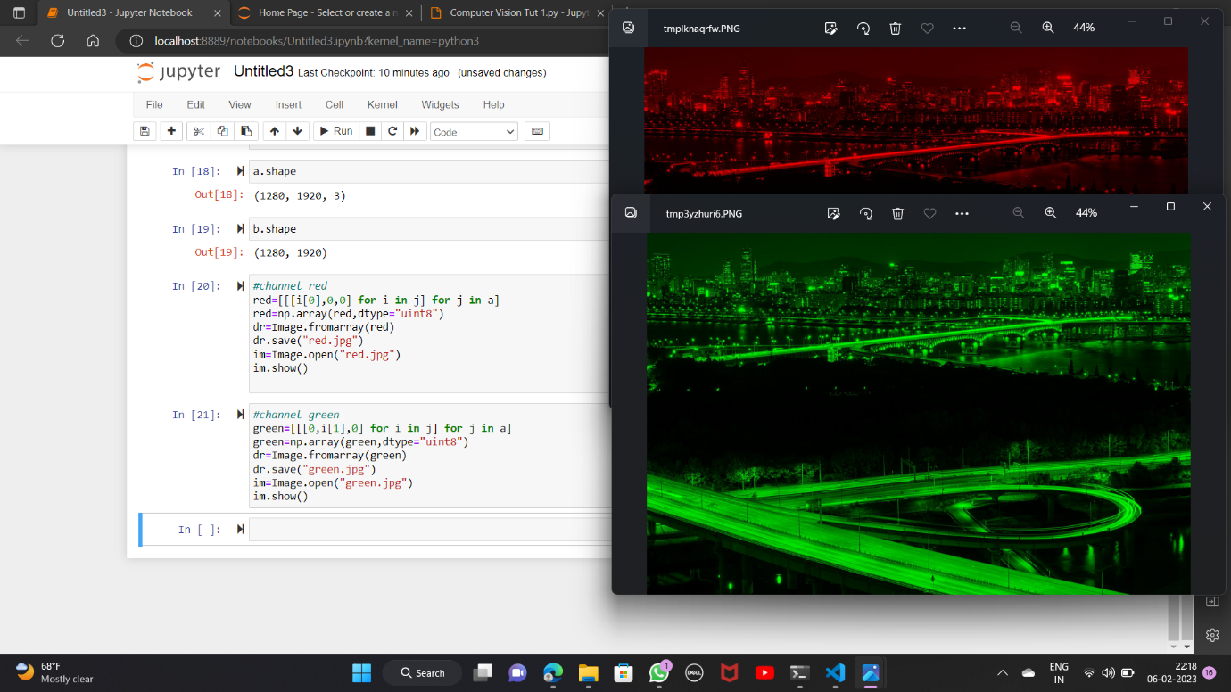

#channel blue

blue=[[[0,0,i[2]] for i in j] for j in a]

blue=np.array(blue,dtype="uint8")

dr=Image.fromarray(blue)

dr.save("blue.jpg")

im=Image.open("blue.jpg")

im.show()

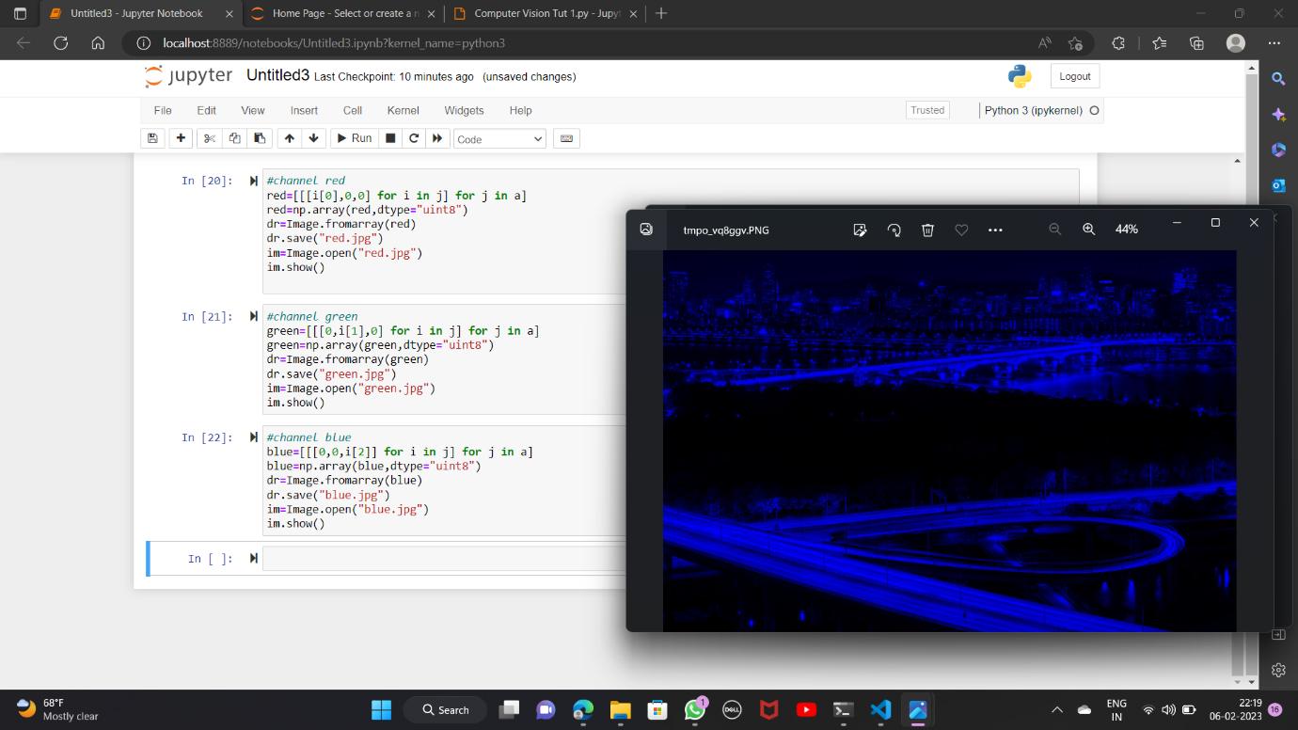

im_new=[[a[i][j] for j in range(1486,1586)] for i in range(1102,1202)]

im_new=np.array(im_new,dtype="uint8")

im_new.shape

#mid 100 pixels

im_new=Image.fromarray(im_new)

im_new.save("im_new.jpg")

im=Image.open("im_new.jpg")

im.show()

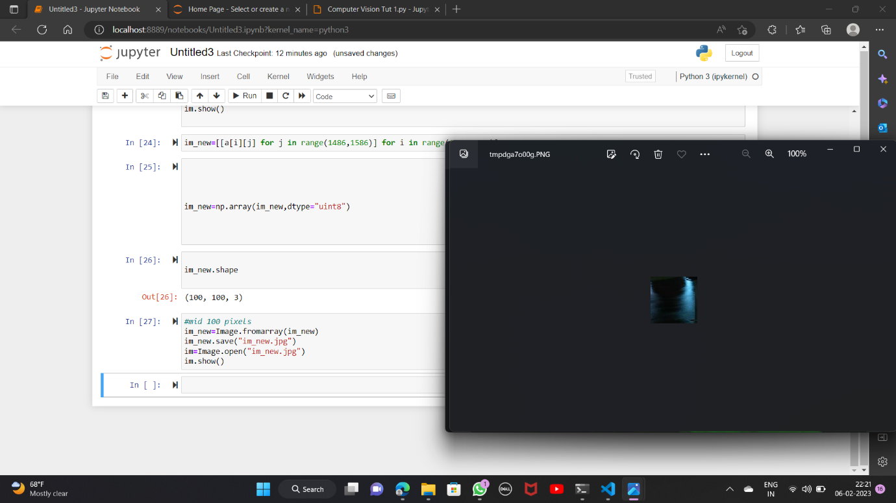

array=np.zeros((2304,3072,3),dtype="uint8")

for i in range(0,2304,10):

    for j in range(0,3072,20):

        array[i][j]=a[i][j]

#10 and 20

im_new=Image.fromarray(array)

im_new.save("im_new.jpg")

im=Image.open("im_new.jpg")

im.show()

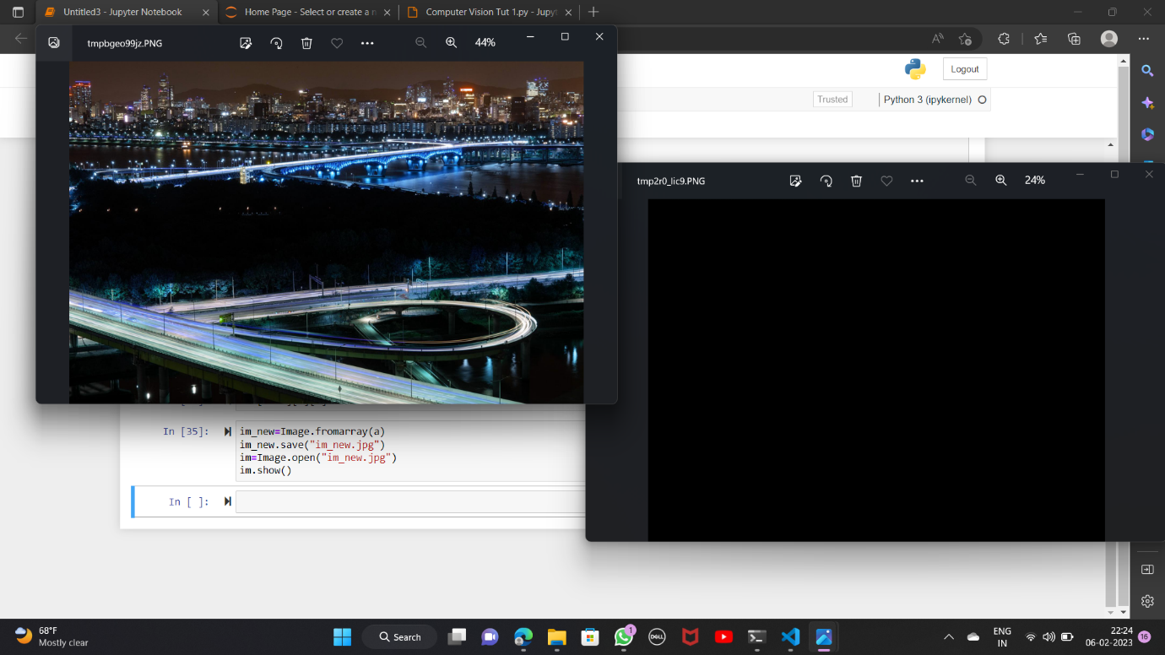

b=a[::-1][:][:]

#flip vertically

im_new=Image.fromarray(a)

im_new.save("im_new.jpg")

im=Image.open("im_new.jpg")

im.show()

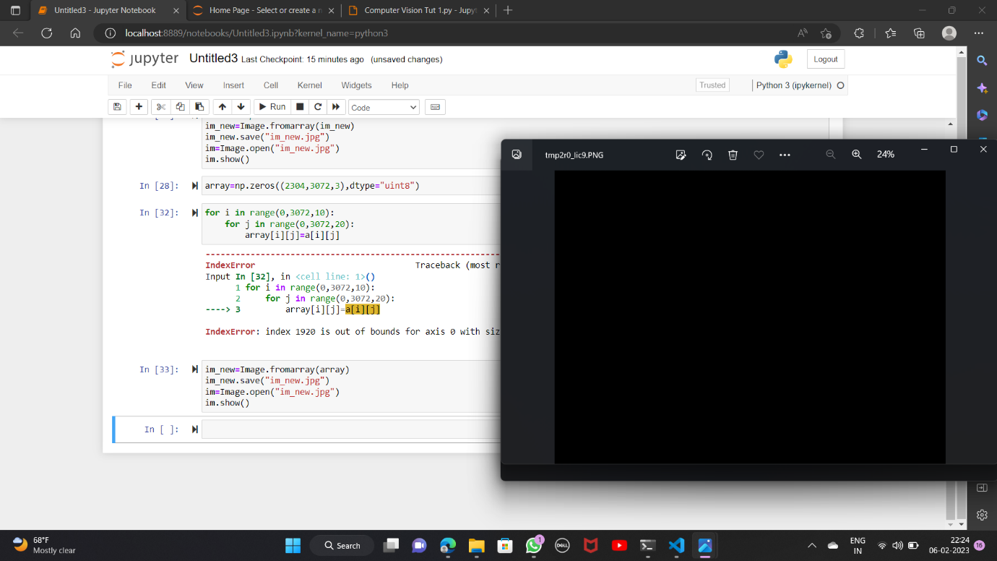

#image histogram

import matplotlib.pyplot as plt

n=cv2.imread(r"nature.jpg",0)

plt.hist(n.ravel(),256,[0,256])

plt.show()

